Let’s Build the Cloud, One Server at a Time!
GHC 2018 Workshop Instructions for Servers 12-17
Niharika MATETI, RADHIKA SAKSENA, AKANKSHA GUPTA
2018

Instructions for Servers labeled 12-17

Before you begin
- In this workshop you will be removing the components of a server and assembling it back. The workshop is for 30 minutes. You can take time to explore the server, but please ensure to put back all the components inside the server and close the top cover at the end of 30 minutes.
- Please take turns around the table for each instruction.
- The round label on the top of the server shows the server model and generation. The printed instructions provided to you are for the model of the server on your desk. If you believe you may have received instructions for a different model, please bring it to the presenters’ attention.
- You may need to apply some force to snap things into place. But if you are applying too much force or if you are not able to pull the components out, then you are doing something wrong. Check the instructions and try again.
- There are volunteers around to help you if you require any assistance.
- In most cases, you will not require a screwdriver. You should be able to loosen the thumbscrews easily. But if you need one, please ask the volunteers or the presenters for one.
- If you have a DL380p Gen8, study Figure 1 to understand the system board components and their location.
- If you have a DL380e Gen8 study Figure 2 to understand the system board components and their location.
- On some servers there is additional information on the bottom side of the top cover.
Removal Instructions
- Remove the top cover from the server.
- Lift the latch on the top cover.
- Slide the cover toward the rear of the server and then lift to remove the top cover from the chassis.
- Remove the air baffle. The air baffle is a plastic cover that goes over the processors and memory.
  - See Figure 6
  - Pinch both locking latches to unlock the air baffle from the heat sink cages.
  - Lift the air baffle straight up and out of the chassis to remove.
- Remove the 2 RAM DIMMS.
- See Figure 3 for a picture of a DIMM.
  - Open the DIMM slot latches located at the edges.
  - Lift the DIMM up and out of the DIMM slot.
- Remove all the fans.
  - See Figure 10
  - Grasp the fan by the finger grooves.
  - Pull the fan straight up and out of the fan cage.
- Remove the power supply. Some servers have 2 power supplies, remove both of them. The power supplies are at the back of the server.
  - See Figure 15 for a picture of the power supply.
  - Press the release tab toward the left.
  - Grasp the power supply handle and pull the power supply from the bay
- Remove the PCI riser cage.
  - See Figure 8.
  - Loosen the two PCI riser cage thumbscrews by lifting the tabs and rotating them counter clockwise, 180 degrees until the thumbscrews pop up and disengage from the system board.
  - Lift up evenly on the PCI riser cage to unseat the PCI riser boards from the system board and remove the PCI riser cage from the server chassis.
- Remove the PCI card from the PCI riser cage.
  - See Figure 12. Note: instead of a blank in the figure, there will be a PCI card.
  - See Figure 13 for a picture of a PCI card.
  - Press the blue release tab and open the expansion board locking mechanism.
  - Carefully pull the expansion board (PCI card) out of riser card expansion slot.
- Remove the hard drive. The hard drives are in the front of the server. There is just 1 hard drive.
  - Press the red ejector button to release the handle.
  - Use the handle to slide out the hard drive.

Installation Instructions
- Install the Fans.
- See Figure 11.
  - Grasp the fan by the finger grooves.
  - Orient the fan with the air flow arrows on top and pointing toward the rear of the server.
  - Lower the fan straight down into the fan cage until it is fully seated and clicks into place.
- Install the 2 RAM DIMMs. Check the number of processors installed in you server. If only 1 processor is installed, place the 2 DIMMs according to the alphabetic order (A and B slot for processor 1). If 2 processors are installed, place each of the DIMMs in the A slot of each processor.
  - See Figure 3 for DIMM Installation
  - See Figure 4 for DIMM slots for a DL380p Gen8 server.
  - See Figure 5 for DIMM slots for a DL380e Gen8 server.
  - Ensure that the DIMM slot latches are open.
  - Locate the alignment notch on the DIMM and align it with the key in the DIMM slot.
  - Push the DIMM down firmly into the slot until the DIMM slot latches snap into place.
  - Ensure that the DIMM is fully inserted and properly seated in the slot.
- Insert the power supply into the power supply slot.
  - See Figure 15
  - Slide the hot-plug power supply into the power supply bay until it is fully seated and clicks into place.
- Install PCI expansion board into the PCI riser cage.
  - See Figure 14.
  - Gently push the expansion board into the riser card expansion slot. Find a slot which is empty. Ensure that the PCI card is fully inserted.
  - Close the expansion board locking mechanism and press the blue release tab.
- Install the PCI riser cage.
  - Check Figure 9.
  - Replace the PCI riser cage into the server chassis to seat the PCI riser boards into the system board.
  - Tighten the two PCI riser cage thumbscrews and rotate them clockwise, 180 degrees until the thumbscrews engage into the system board.
- Install the hard drive into bay 1. On some servers, check the front of the server for the hard drive bay numbering. On other servers there is a label on the top of the server which shows the hard drive bays numbering.
  - Press the ejector button to release the handle.
  - With the hard drive handle extended, insert the drive into the drive bay.
  - Close the drive handle to lock the hard drive into place.
- Replace the air baffle.
  - See Figure 7 for air baffle installation.
  - While pinching the locking latches, align the air baffle with notches in the fan cage and lower it into place over the DIMM slots.
  - Stop pinching the locking latches to lock the air baffle to the top of the heat sink cages.
- Replace the top cover.
  - To replace the top cover, align it to the chassis then slide it toward the front panel.
  - The latch should be open while sliding the cover.

DL380p Gen8 System Board Components
Figure 1: DL380p Gen8 System Board Components

Item | Description
1 | Fan connector 6
2 | Systems Insight Display connector
3 | Fan connector 5
4 | Processor 1 DIMM slots
5 | Fan connector 4
6 | Front I/O connector
7 | Front USB connector
8 | Fan connector 3
9 | First drive cage, box 2 power connector
10 | Fan connector 2
11 | Processor 2 DIMM slots
12 | Second drive cage, box 1 power connector
13 | Fan connector 1
14 | Discovery services connector
15 | Front video connector
16 | USB connector
17 | Power supply backplane connector
18 | SATA optical drive connector
19 | NMI jumper
20 | System battery
21 | SD card slot
22 | Secondary (processor 2) PCI riser connector
23 | System maintenance switch
24 | Processor 2 socket
25 | TPM connector
26 | Primary (processor 1) PCI riser connector
27 | FlexibleLOM
28 | SAS connector 1
29 | SAS connector 2
30 | Cache module connector
31 | Processor 1 socket
32 | RDX power connector

DL380e Gen8 System Board Components

Figure 2: DL380e Gen8 System Board Components

Item | Description
1 | PCI riser connectors
2 | Cache module connector
3 | TPM connector
4 | Mini-SAS connector
5 | SATA drive connector
6 | System battery
7 | SATA optical/storage drivel connector
8 | Front panel connectors
9 | Primary GPU power connector
10 | Not applicable
11 | Fan connector 6
12 | Fan connector 5
13 | Fan connector 4
14 | Not applicable
15 | Internal USB connector
16 | Fan connector 3
17 | Fan connector 2
18 | Fan connector 1
19 | Processor 2 DIMM slots
20 | Processor socket 2
21 | Discovery service connector
22 | Drive backplane power connector
23 | Drive sideband signal connector
24 | Secondary GPU power connector
25 | Power supply connector 1
26 | Power supply connector 2
27 | Processor socket 1
28 | Processor 1 DIMM slots
29 | SD card slot
30 | NMI header
31 | System maintenance switch

Installation of a DIMM

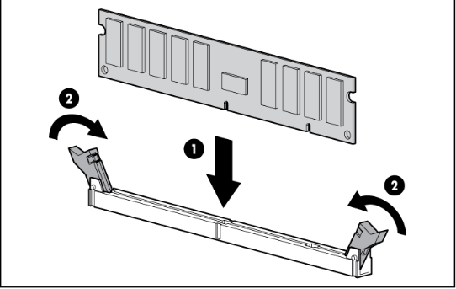
Figure 3: Install a DIMM

DL380p Gen8 DIMM Slots
Figure 4: DL380p Gen8 DIMM Slot Locations

DL380e Gen8 DIMM Slots

Figure 5: DL380e Gen8 DIMM Slot locations

Remove the air baffle

Figure 6: Remove Air Baffle

Install the air baffle

Figure 7: Air baffle installation
Remove the PCI riser cage

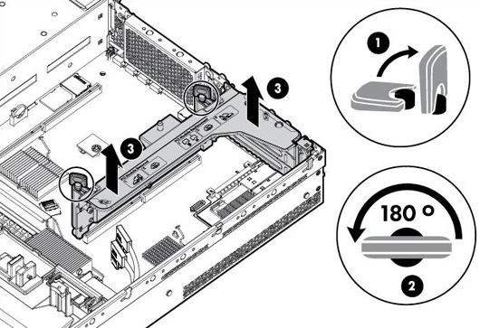
Figure 8: PCI riser cage removal

Install the PCI riser cage

Figure 9: PCI Riser Cage Installation
Remove Fans
Figure 10: Fan removal
Install Fans
Figure 11: Fan installation

Remove PCI Card

Figure 12: Remove PCI Card

PCI
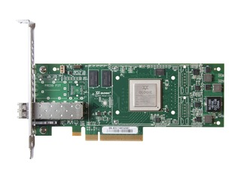
Figure 13: PCI expansion card

Install the PCI Card
Figure 14: PCI Card Installation

Power supply
Figure 15: Insert Power Supply

